
Collaborative Leadership Workshop
January 2009, IBM Raleigh
Course materials can be found on www.accelinnova.com/classdev.html
Objective
To provide tools and techniques to enable leaders to improve their collaborative leadership practices, increasing business value to their organization

Agenda-Day One
8:30 – 9:00 Introduction

The Practices of Collaborative Leaders

9:00 – 10:30 Collaboration and Leading Collaboration

10:30 – 10:45 Break

10:45 – 12:00 Stepping Back and Stepping Up

12:00 – 12:30 Lunch

12:30 – 13:30 Creating a Culture of Trust

Applying Collaborative Leadership

13:30 – 15:00 The Collaborative Leader and Decision Making

15:00 – 15:15 Break

15:15 – 16:15 The Collaborative Leader and Problem Solving

16:15 – 17:15 The Collaborative Leader and Risk Management

17:15 – 18:00 Feedback

Agenda-Day Two

8:30 – 11:30 Putting Leadership Tools To Work

Introduction
How can leaders increase their ability to:
- Build a sustainable competitive advantage
- Unleash the potential and maximize the effectiveness of our teams


Collaborative Leadership

What it means
Old School Leader knows it all vs New School Leader who focuses building ownership within the team.
Key Steps:
- Create an Open Environment
- Get the right people on the team
  - Engaged/enthusiastic
  - From all appropriate disciplines
- Foster innovation through collaborative approaches
- Step back and let the team work.

Collaboration Tool
A tool for quickly coming to a common view and priority on any topic.
- Agree to the goal, objective, or problem to be solved.
- Using sticky notes and marking pens, each person brainstorms their answers, one answer on one sticky note, as many notes as they need.
- Have each person read their out loud to the group as they stick each note on the wall or whiteboard.
- Ask the entire team to group the notes – in silence. Give them no other directions than that.
- As a team, label the groups with a title they all agree to.
- Add up the number of groups, divide by three, and round up. This is the number of votes each person has to vote for the most important or best solutions.
- Let each person vote next to the title. Make sure they understand that they can put more than one vote on a group if they feel it had great importance to them.
- Tally up the votes.
- Break up into small teams and work on how you can implement the highest voted groups, each breakout team taking a different group and then reporting out their results to the full team.
- Work through all relevant groups.
- Let people decide what tasks they want to do and by when. Stress they should take on tasks they want to do. Remaining tasks they no one wants to do should be resolved by the full team.


Leading Collaboration
The ‘best’ people have:
- Passion
- Best skills
- Organizational fit

Attract & Retain priorities in order
- Integrity
- Motivation
- Capacity
- Understanding
- Knowledge
- Experience

Energize the team
- Build Authenticity / Attitude / Intelligence / Talent
- Trust First – essential to get the process going
- Enable teams to make decisions wherever possible
- Step aside and let them work

If not authoritarian - What is the leadership role?
- Keep the purpose alive
- Keep focus through questions
- Operate with total transparency – OVER communicate
- Fix processes – not people
- Give feedback that honors the relationship
- Operate through influence, not authority – don’t take ownership away from the team
- Remove obstacles from the team
- Expect Success / Accept mistakes
- Take the FUN out of being Dysfunctional
- Fail Early Fail Fast
- Remove all blame
- Fall Forward – continuously learn from mistakes / problems

Collaborative Leadership Summary
- Autocracy dampens people’s creativity and motivation
- Need to give up Command & Control to build Team Ownership
- Free the team to Investigate, Analyze & Investigate
- The opposite of control is discovery
- Build a place where people want to be
- Get the team what they need to succeed
- Unleash the team

Step Back / Step Up
How do you step back and let the team work? When and how should you step up?

How to Step Aside
- Give ownership to the team
- Use Authentic Motivation
  - Get teams to collaborate & make decisions
  - Let people choose how, what and when as much as possible
  - Provide meaningful work
- Create a Culture of Trust
- Let the teams figure out “how” when they understand the “what”
- Create a safety net for the team
- Get the “right” people on the bus - ensure engagement and commitment

What to do when the team needs help
- Keep the focus by asking questions
- Maintain team integrity – don’t take ownership away from them
- Use their problem solving ability
- Bring the team together
- Ask the team to describe their work, approach, the path they took and why
- Help them discover a new view


Boundary Cube Model / Macro Leadership Model
- Define the team’s boundaries and let them operate within them
- Focus on removing barriers for them
- Adjust the boundaries over time based on team results
- Example Boundaries: Business Value ( see below ), Budget, Purpose, Market Window, Considerations ( See later )
- Focus on results – not on managing the internal progress
- As the teams grow – step back further
- If they hit the boundaries
  - Don’t rescue the team
  - Don’t give answers
  - Ask questions like …
    - What would you like me to do? ( Ensure they have ownership )
    - How would you like to solve it?
  - Tell stories

Creating a Culture of Trust

You can’t make people trust each other – so how can you help them build trust? Leaders can create a culture that fosters trust.

A Lack of Trust Costs
- Transaction costs go up
- Significant effort is spent on self-protection
- Decision making slows

Can The Team Work Together?
- Find out if there is broken trust in the team or if trust is not yet built.
- Who talks to whom? Who listens?
- Do you have a “difficult” (untrusted) person on the team?
- Do you still need them? – find out with the vacation test.
- If you don’t then – find them another job elsewhere. Off the bus.
- If you do – build an island or work with the remainder of the team to figure out how to “integrate” them.

Create a Culture of Trust
- Remove Debilitating Fear
  - Loss of Personal Value << no chart for this >>
  - Loss of Identity
  - Loss of Intellectual Mastery
  - Loss of Individualism
- Use Team Based Results Measurements
  - Let the team evaluate themselves for improvement – sharing with management is optional
- Build Confidence
  - Protect team boundaries
  - Short iterations
  - Early wins
  - Focus on purpose over personal agenda
  - Be trustworthy and honest
  - Stay positive
  - Focus on magnifying a person’s strengths not fixing their weaknesses
  - Give continuous feedback

Decision Making

Collaboration needs a way of building a common view of business value. In traditional Cost/Benefit models, costs are an estimate, benefits are a guess, so predicted E/R is highly unreliable.

The Purpose Model
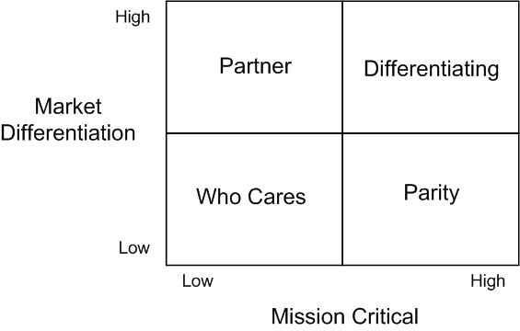

Use the 5 questions:
- Who do we serve and what do they want and need most?
- What do we provide to help them?
- What is the best way to provide this?
- How do we know we are succeeding?
- How should we organize to deliver?

Billboard Test
- Will we brag about this to our customers?

Decision Filters
- Propagate throughout the organization for aligned decision making

Caveats
- Parity is mission critical
- Treat exceptions as exceptions
- Differentiating changes over time
- Differentiation requires continuous innovation

The New Business Value Model

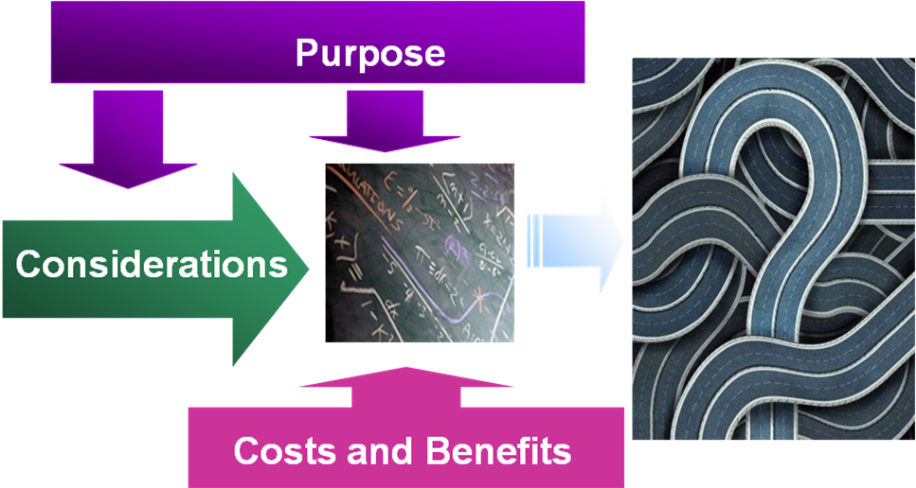

- Get the key players together
- Start from the Purpose of the investment
- Use the 5 Questions and Billboard to focus
- Add Considerations
- Add Cost Benefit Estimates
- Discuss and Collaborate until a common view is reached
- Group into “Chunks”
  - Chunk content can be selected to include learning
- Check inputs of model. Changed? Adjust model
- Evaluate value of completed chunk
- Ask the question:
  - Do we have enough value to do to market?
  - Should we continue?
  - If so, what goes into the next chunk?
  - If not, stop.
- Re-evaluate and ask after every delivery

Notes


Managing Risks
- Understanding of Risks continually changes
- Every project is different
- Focus on Uncertainty factors and Complexity to continuously manage risk

Uncertainty / Complexity Model
Examples – Select the Risks and Scales that work for you
Complexity | Uncertainty
- Team Size | - Market Uncertainty
- Mission Criticality | - Technical Uncertainty
- Geographically Dispersed | - Project Duration Uncertainty
- Team Capacity | - Dependents
- Skills | - Number of Customers
- Dependencies | - Amount of Change
- Team Maturity | - Dependents / Scope Flexibility
- Stack Size | - Resource / Skills Availability
- Algorithm Complexity | - Market Requirements
- Multiple Goals | - Market Opportunity
- Variation of Time Zones | - Dependencies
- Organizational Match Dependent's Needs

Bibliography

Books, Articles and Related Links
Find it all here: www.accelinnova.com/classdev.html

Stand Back and Deliver: Tools for Leading Change. Book by Pollyanna Pixton, Niel Nickolaisen, Todd Little, and Kent McDonald, Spring 2009, Addison-Wesley. Final Draft version can be found at Accelinnova.com.

Collaboration and Collaborative Leadership

21st Century Jet – Making the Boeing 777 (video) http://video.google.com/videoplay?docid=3551731641323350192
- Seven-day Weekend: Changing the Way Work Works. (book) Ricardo Semler, Portfolio, 2004.
- Organizing Genius: The Secrets of Creative Collaboration. Warren Bennis, Addison-Wesley, 1997.

Stepping Up and Stepping Back
- “When to Step Up, When to Step Back” article by Pollyanna Pixton, Better Software, May 2008
- “How I Learned to Let My Workers Lead” article by Ralph Sayers, Harvard Business Review, November-December 1990
- “How Pixar Fosters Collective Creativity” article by Ed Catmull, Harvard Business Review, September 2008
- Punished by Rewards: The Trouble With Gold Stars, Incentive Plans, As, Praise, and Other Bribes. Book by Alfie Kohn, Replica Books (August 2001)
“Kohn derides rewards as bribes and offers instead the proposition that collaboration (teamwork), content (meaningfulness), and choice (autonomy) will serve to motivate both students and workers.”

Creating a Culture of Trust
- "Creating a Culture of Trust" article by Pollyanna Pixton, Better Software, September 2008
- Orbiting the Giant Hairball: A Corporate Fool's Guide to Surviving with Grace. Book by Gordon McKenzie, Viking Adult; 1 edition (April 1, 1998)
“Gordon McKenzie worked at Hallmark Cards for thirty years, many of which he spent inspiring his colleagues to slip the bonds of Corporate Normalcy and rise to orbit--to a mode of dreaming, daring and doing above and beyond the rubber-stamp confines of the administrative mind-set.”

Making Better Decisions
- "A Maverick Approach to the Business Value of IT" article by Audrey L. Apfel, Gartner Research, 29 April 2008
- Good to Great: Why Some Companies Make the Leap . . . and Others Don’t. Jim Collins, New York: HarperBusiness, 2001. http://www.jimcollins.com/
Based on a five-year research project, Good to Great answers the question: “Can a good company become a great company, and, if so, how?” True to the rigorous research methodology and invigorating teaching style of Jim Collins, Good to Great teaches how even the dowdiest of companies can make the leap to outperform market leaders the likes of Coca-Cola, Intel, General Electric, and Merck.
Excellent description on Level 5 leadership and “Right Person in the Right Seat on the Bus.”

Managing Risk
- "Wicked Problems: Naming the Pain in Organizations" article by E. Jeffrey Conklin & William Weil, White Paper, Touchstone Tools and Resources
- “How to Spot a Failing Project” article by Rick Cook, CIO.com, July 17, 2007
- “The 6 Myths of Creativity” Interview by Bill Breen, FastCompany, December 2004

