Collaborative Leadership Worksheet
January 2009, IBM Raleigh
Course materials can be found on www.accelinnova.com/classdev.html


Collaborative Leadership

What it means
Old School Leader knows it all vs New School Leader who focuses building ownership within the team.

Most Important for an Open Environment?

Notes:

Step Back / Step Up
How do you step back and let the team work? When and how should you step up?

Step Back Red Flags: What kinds of things do you see in your organizations when you know it’s time to Step Back and let teams work?
________________________________________________________________________________

Step Up Red Flags: What kinds of things do you see in your organizations when you know it’s time to Step Up and lead?
________________________________________________________________________________

“I’m not going to rescue” Questions: What questions would you ask your teams to help them discover their own solutions?

Creating a Culture of Trust

You can’t make people trust each other – so how can you help them build trust? Leaders can create a culture that fosters trust.

How do you define trust?

Teams without trust look like…

What do people fear: In your organization and on your team?

Decision Making
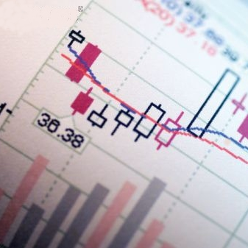
Collaboration needs a way of building a common view of business value. In traditional Cost/Benefit models, costs are an estimate, benefits are a guess, so predicted E/R is highly unreliable.

Pick a project/idea/product

What’s the Purpose?

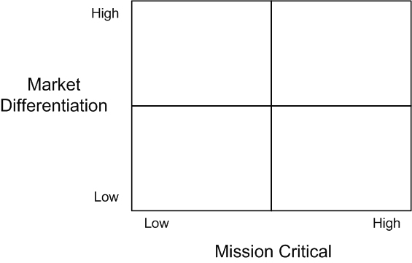

Use the 5 questions:
- Who do we serve and what do they want and need most?
- What do we provide to help them?
- What is the best way to provide this?
- How do we know we are succeeding?
- How should we organize to deliver?

What’s on Your Billboard?

The New Business Value Model

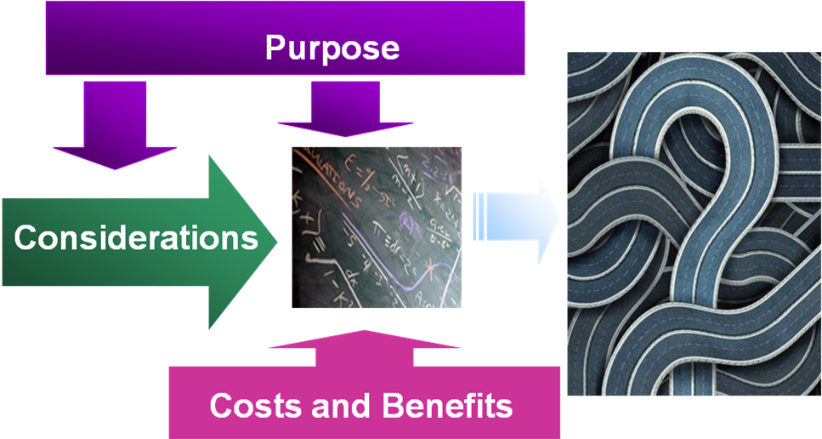

Your Considerations? Prioritized.

Cost and Benefits?

How did you quality Cost and Benefits?

Largest Value “Chunks”?

What can you defer?


Managing Risks
- Understanding of Risks continually changes
- Every project is different
- Focus on Uncertainty factors and Complexity to continuously manage risk

Where is your project/idea/product?

Uncertainties and Level?
1 3 5 7 10

0
1
2
3
4
5
6
7
8
9
10

Complexities and Level?
1 3 5 7 10

0
1
2
3
4
5
6
7
8
9
10

