
Collaborative Leadership
Tools at Work

Course materials can be found on www.accelinnova.com/classdev.html

Pick a project/idea/product

What’s the Purpose?

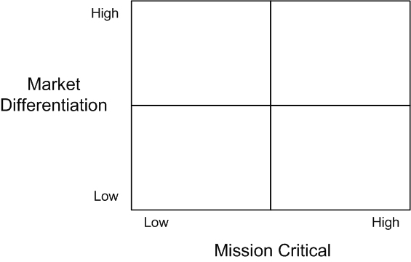

Use the 5 questions:
- Who do we serve and what do they want and need most?
- What do we provide to help them?
- What is the best way to provide this?
- How do we know we are succeeding?
- How should we organize to deliver?

What’s on Your Billboard?

The New Business Value Model

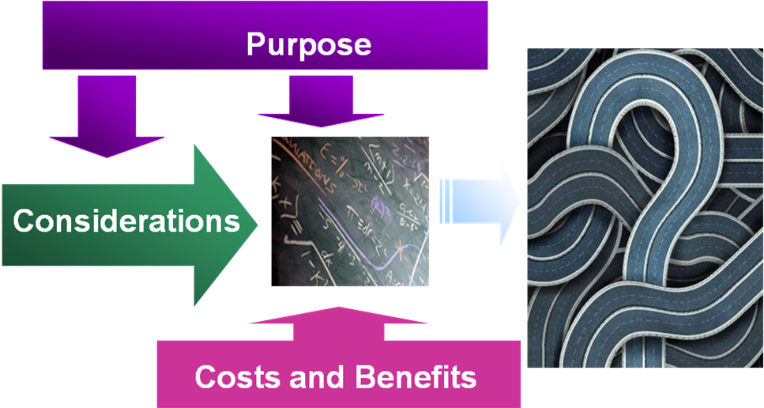

Your Considerations? Prioritized.

Cost and Benefits?

Largest Value “Chunks”?

What can you defer?


Managing Risks
- Understanding of Risks continually changes
- Every project is different
- Focus on Uncertainty factors and Complexity to continuously manage risk

Where is your project/idea/product?

Uncertainties and Level?
1 3 5 7 10

0
1
2
3
4
5
6
7
8
9
10

Complexities and Level?
1 3 5 7 10

0
1
2
3
4
5
6
7
8
9
10

